EPDK Energy Sector Cybersecurity Regulation Compliance for Log360
Tagline: Meet EPDK cybersecurity requirements with real-time monitoring from Log360.

Overview
The EPDK Energy Sector Cybersecurity Regulation Compliance extension for Log360 helps Turkish electricity, natural gas, and petroleum market operators regulated by the Energy Market Regulatory Authority (EPDK) meet the sector's cybersecurity monitoring, incident reporting, and control implementation requirements.
Log360 collects and analyzes logs from energy management systems, SCADA environments, IT infrastructure, and network devices, providing security teams with continuous visibility into cyber threats to energy operations. Compliance teams can document ISMS adherence and generate audit evidence for EPDK reporting.

Key Features
- Generate audit reports aligned to EPDK energy sector cybersecurity requirements covering SCADA monitoring, access control, and incident detection for energy systems.
- Monitor operational technology and IT systems for unauthorized commands, anomalous access events, and configuration changes affecting energy operations.
- Configure real-time alerts for energy sector cybersecurity events such as SCADA access violations, privilege escalations, and intrusion indicators.
- Export EPDK-ready compliance evidence in PDF and CSV formats for regulatory submissions and internal energy ISMS governance.
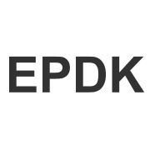


Screenshots
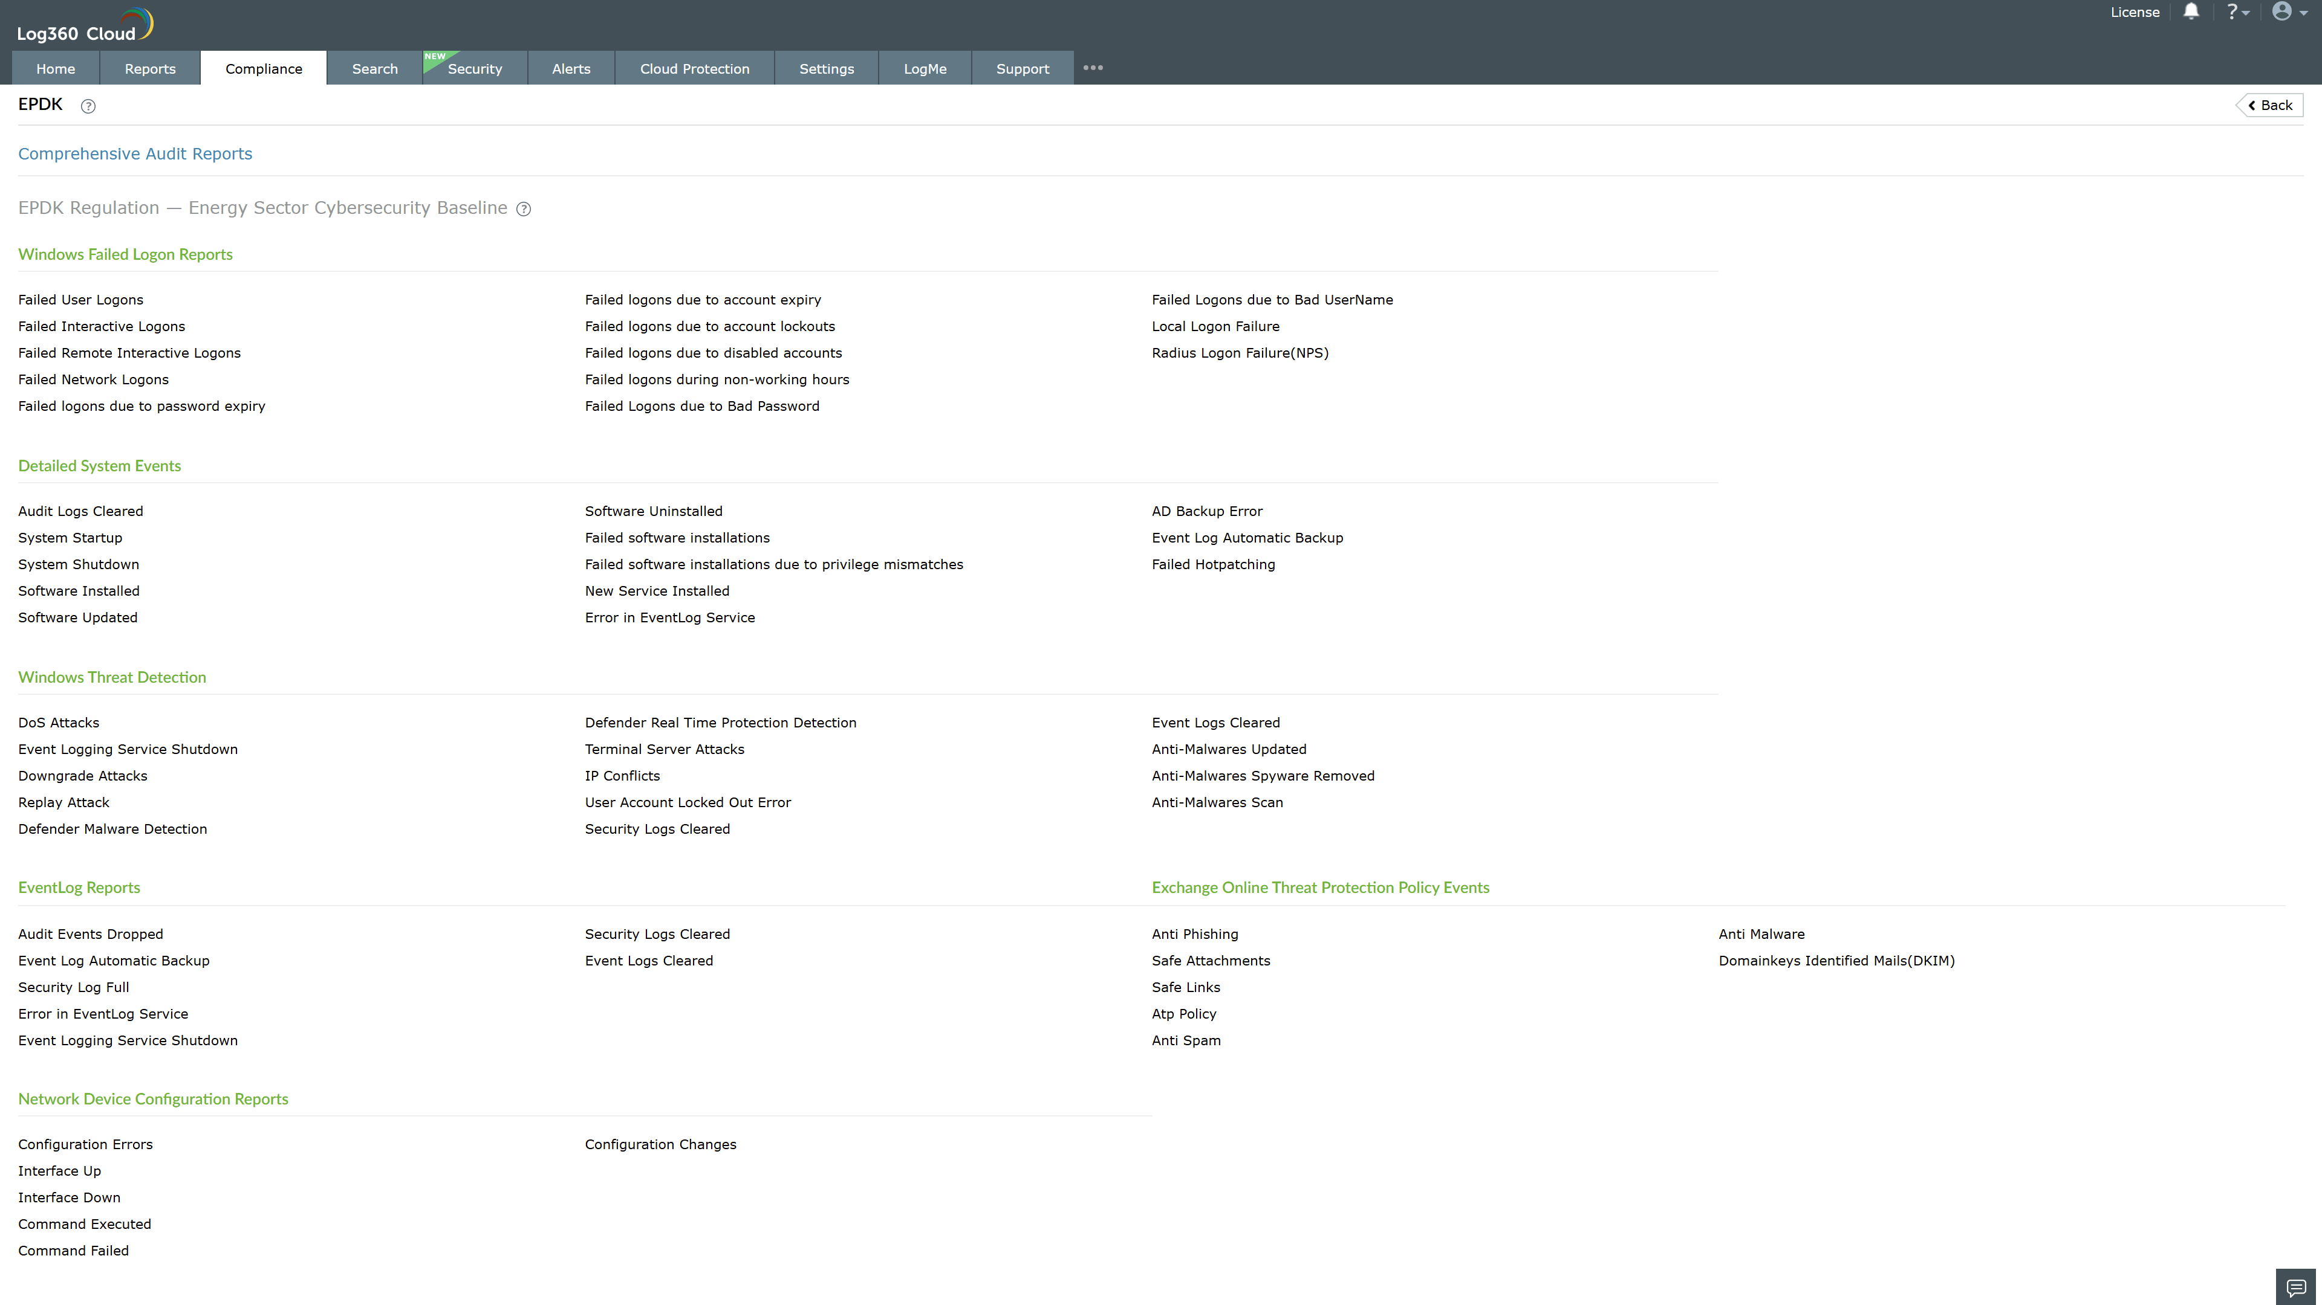
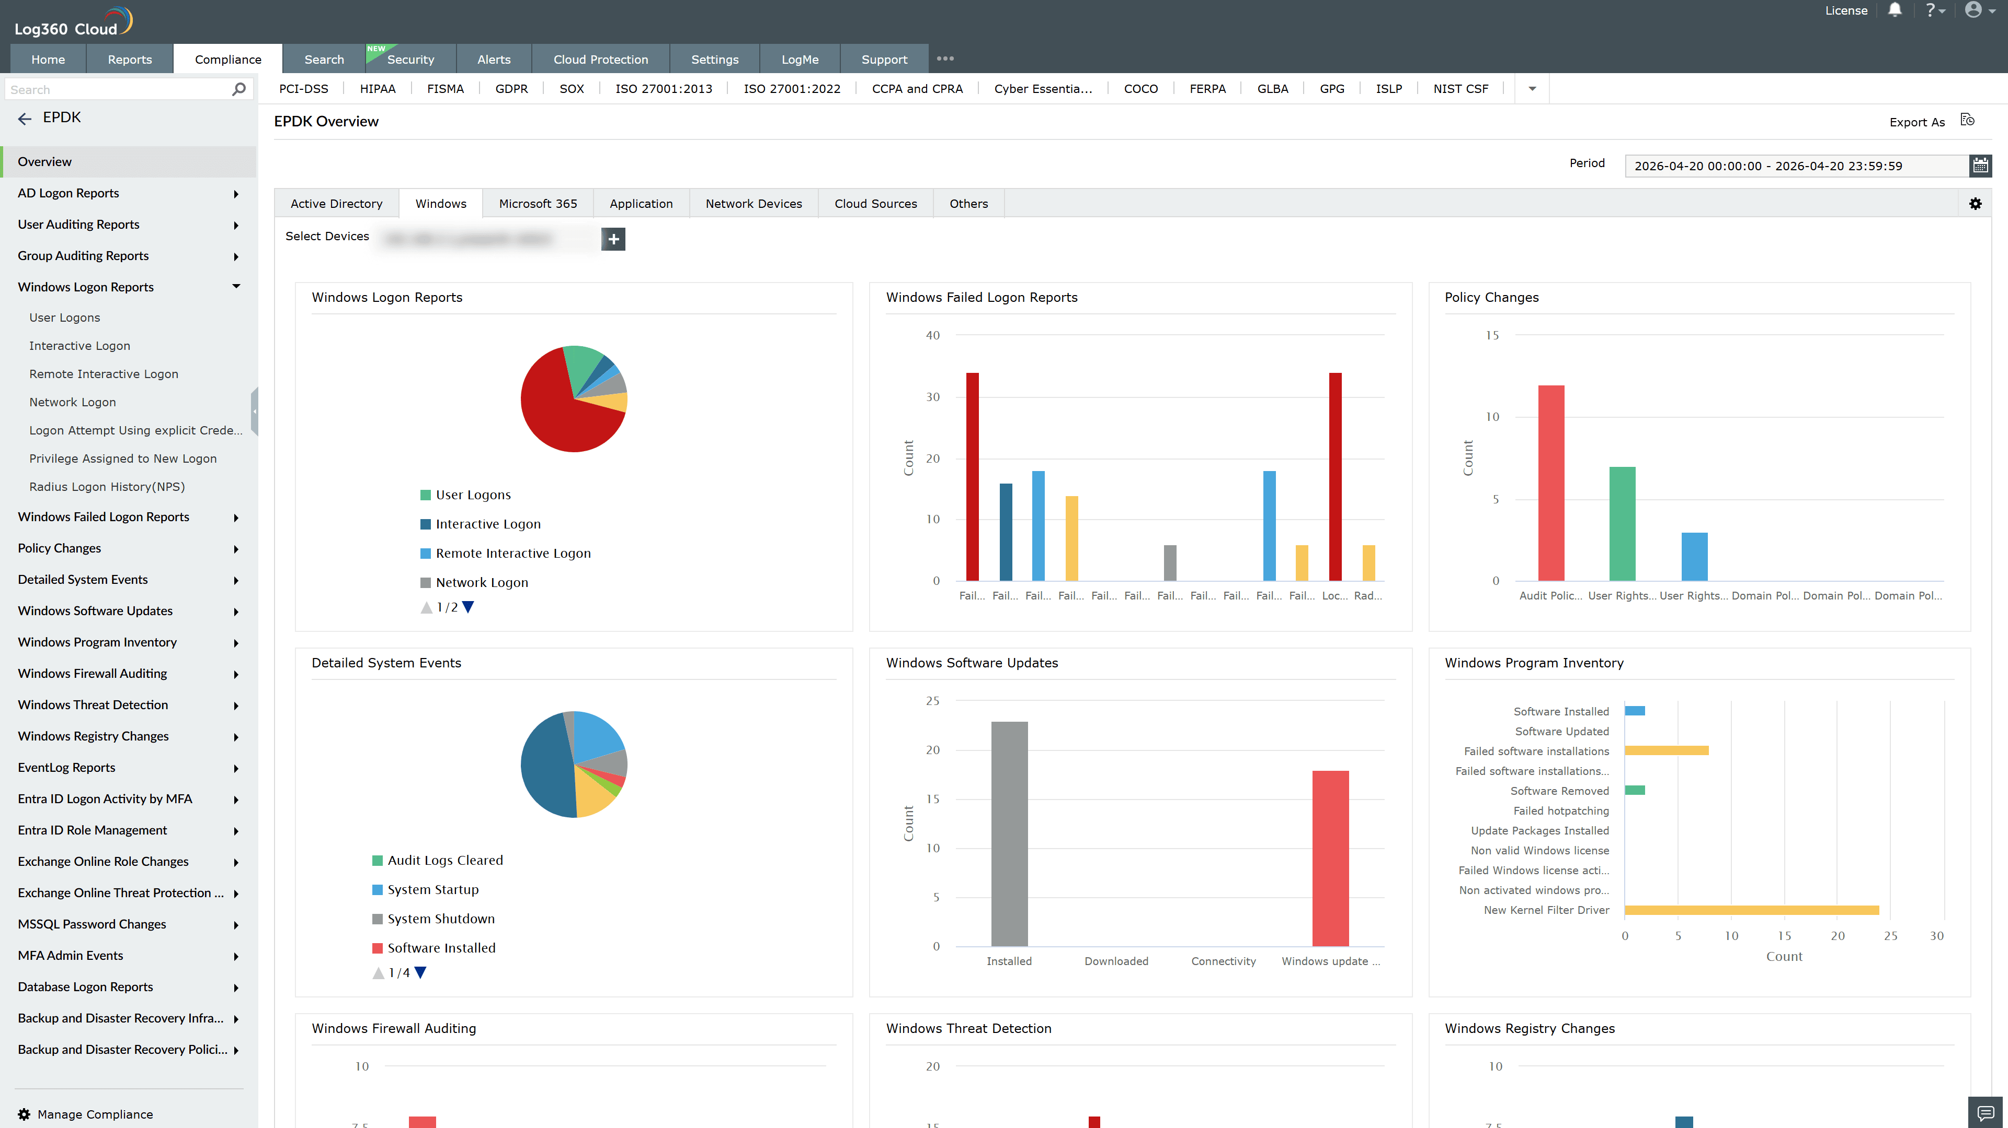
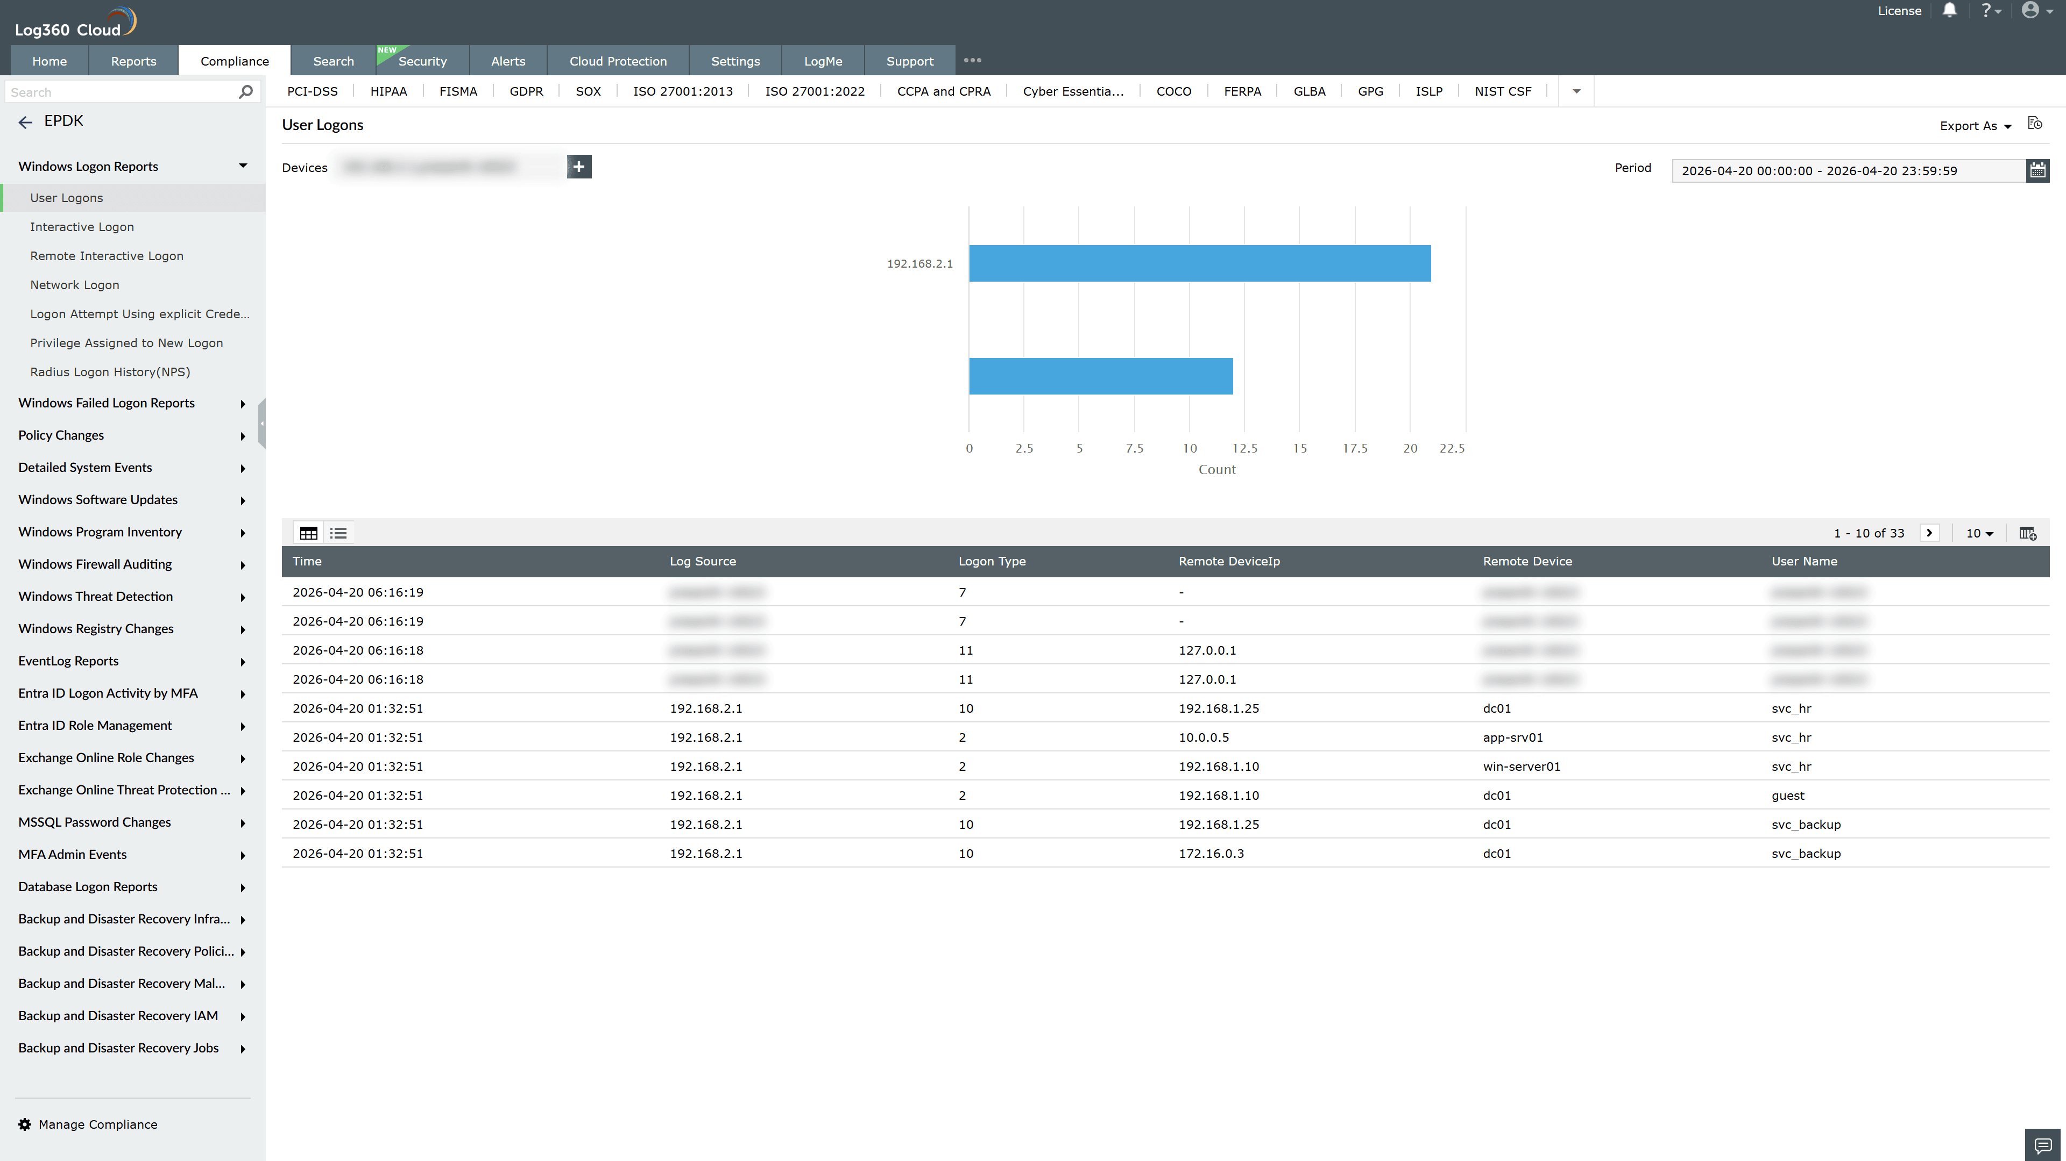
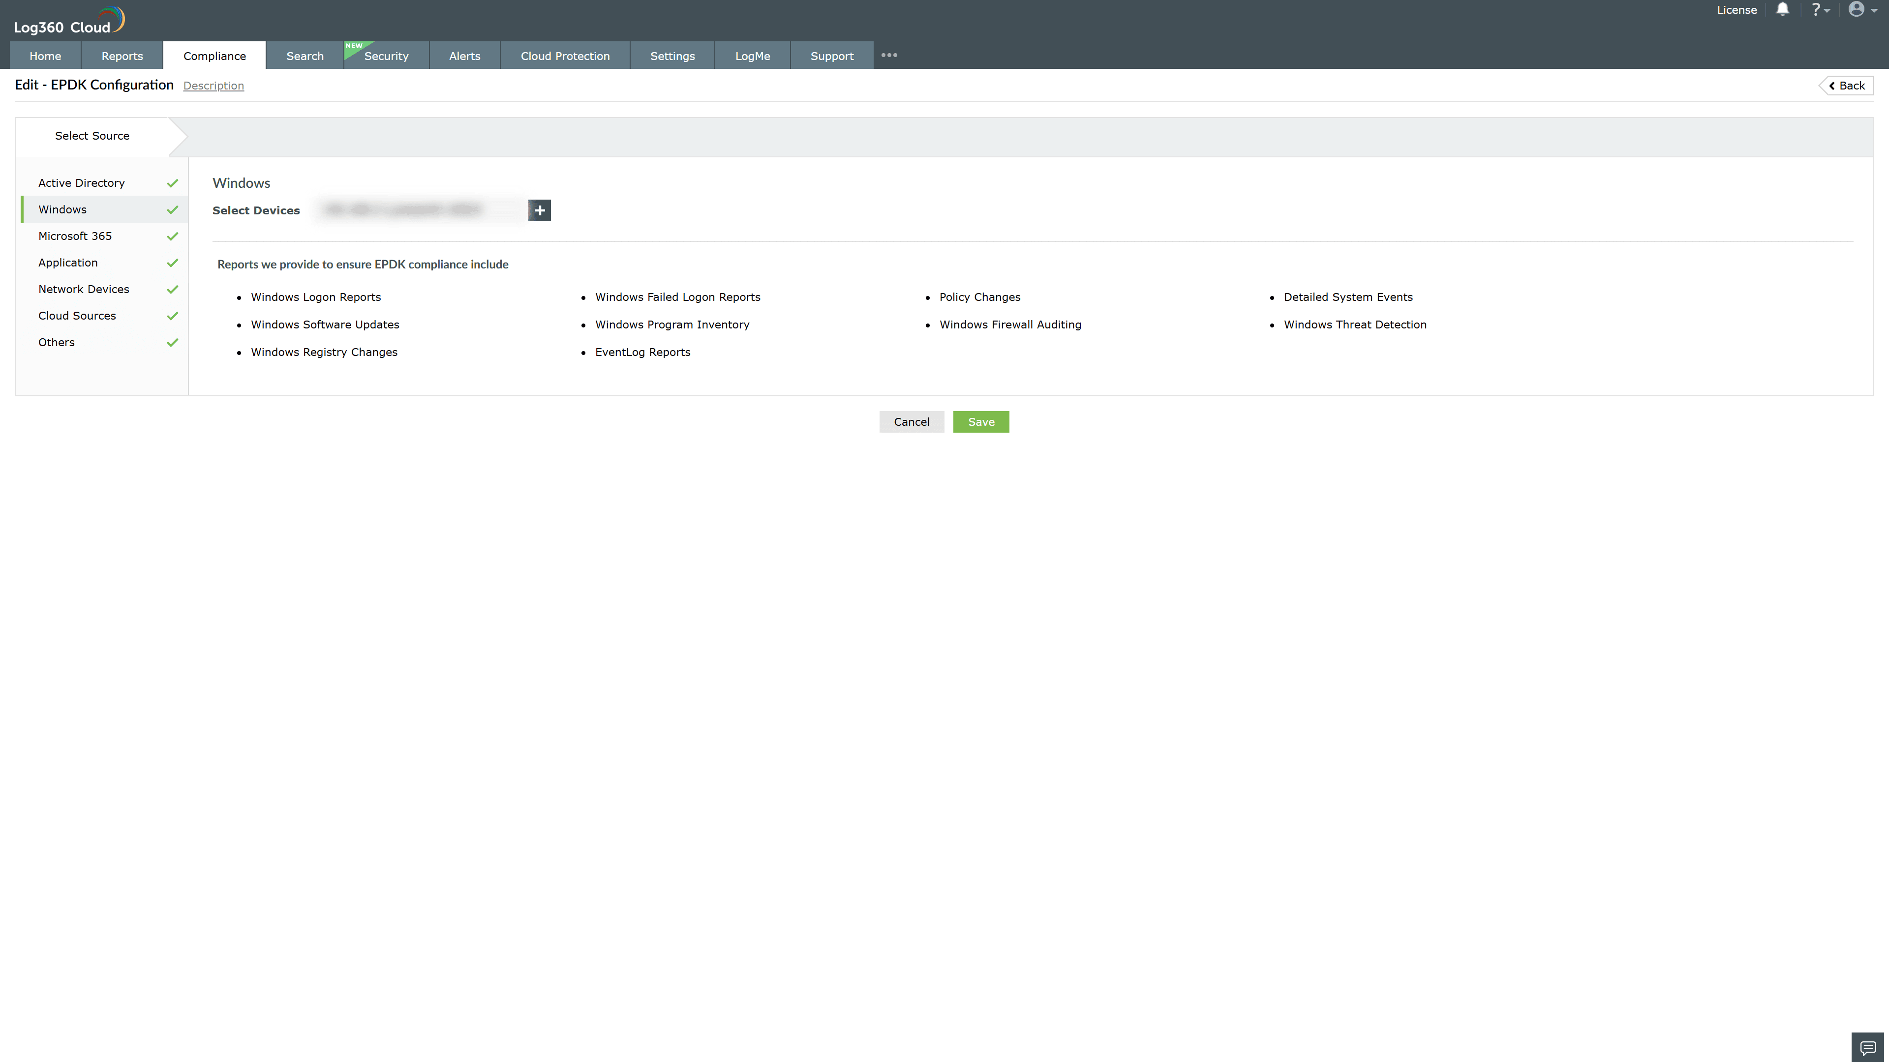

Valid Submission : Yes
Supported Editions : Free, Basic, Standard, Professional, MSSP
Help Document : https://www.manageengine.com/log-management/help/integrations/compliance-extensions.html
Help Video : Not provided
Tags : Log360, Compliance, Privacy monitoring, Data privacy, Regulatory compliance
Supported DCs : US, IN, JP, CA, AU, UK and EU
Privacy Policy:
Terms of Service:
Release Notes:
Predefined reports for the EPDK Energy Sector Cybersecurity Regulation Compliance

